
Sadat Academy for Management Sciences
Faculty of Management Sciences
Major: Management Information System (MIS)

Eco Cycle Website

Supervised by:
Dr. Heba Sabry

Submitted by:
Toka Gamal Abd El-Sadek Gbr
Amir Hisham Salah El-Den
Mazen Khaled Mohamed El-Fateh
Yaseen Mohamed Abd El-Hamed

Contents
Chapter 1 3
Introduction 3
1.1: Overview: 4
1.2: Problem Statement: 5
1.3: Project Objectives: 6
1.4: System Users: 7
1.5: System Requirements: 7
1.5.1: Functional Requirements: 7
1.5.2: Non-Functional Requirements: 8
1.6: Tools Used: 9
Chapter 2 10
System Analysis 10
2.1: Context Diagram: 11
2.2: Use Case Diagram: 13
2.3: Activity Diagram: 15
2.4: Class Diagram: 16
2.5: Sequence Diagram: 23
Chapter 3 27
System Design 27
3.1: Database Design (ERD Diagram): 28
3.2: UI/UX Design (Screen Design): 33
Chapter 4 39
Implementation 39
Chapter 5 50
Conclusion and Future Work 50
5.1: Conclusion: 51
5.2: Future Work: 52

Chapter 1

Introduction

1.1: Overview:
The Eco Cycle project presents an innovative solution to one of the most pressing environmental issues today plastic waste. The aim is to develop a comprehensive and user-friendly website for a start-up that collects, sorts, and recycles plastic into reusable raw materials. By strategically placing plastic collection boxes at partner locations such as universities, malls, restaurants, and supermarkets, the initiative encourages community participation in reducing plastic pollution.
Once the plastic is collected, it is carefully sorted based on quality and recyclability. Only types of plastic that can be effectively processed are accepted. These plastics are then converted into raw materials, which are listed and sold directly through the website. This approach not only supports environmental sustainability but also creates a circular economy by reintroducing recycled materials into the market.
In the near future, the company plans to expand its operations by using 3D printing technology to produce custom-designed items using recycled plastic. These products may include educational models, promotional or decorative items, and functional pieces tailored to partner requests.
The platform serves as an environmental, educational, and commercial tool, promoting awareness, responsible disposal practices, and eco-conscious product consumption. Through this system, Eco Cycle provides a practical, scalable solution to plastic waste while empowering individuals and organizations to be part of the change

1.2: Problem Statement:
Plastic pollution has become a growing global crisis, with millions of tons of plastic waste accumulating in landfills, oceans, and public spaces every year. Traditional waste management systems are often inefficient, overwhelmed, or incapable of properly processing the vast variety of plastics being discarded daily. As a result, a large portion of plastic ends up being burned, dumped, or left untreated—posing severe risks to ecosystems, human health, and future generations.
Despite growing awareness, individuals often lack access to convenient and responsible recycling options. Many do not know which types of plastic are recyclable or where to dispose of them properly. Businesses and institutions may be willing to support sustainability initiatives but lack the infrastructure or know-how to do so effectively.
This project addresses these challenges by providing a structured and accessible system for plastic collection, sorting, and recycling. Through partnerships with various organizations, the start-up installs collection points in strategic, high-traffic locations, making it easier for individuals to participate in sustainable practices. The project focuses on recycling only the plastic types that can be effectively repurposed, transforming them into valuable raw materials or custom-made products.
By simplifying the recycling process and creating an educational and commercial platform, the Eco Cycle project tackles the root of the plastic waste problem and offers a scalable, community-driven solution for a cleaner, more sustainable future.

1.3: Project Objectives:
The primary objective of the Eco Cycle project is to create a practical and impactful platform that empowers individuals and organizations to participate in sustainable plastic recycling. The project aims to bridge the gap between plastic waste generation and responsible recycling through an accessible digital solution.
The specific objectives of the project are:
- To develop a professional and user-friendly website that introduces the startup and clearly communicates its mission, vision, and services.
- To sell recycled raw materials generated from collected plastic through the website, creating a direct link between waste management and material reuse.
- To raise environmental awareness by offering educational content about plastic recycling, acceptable material types, and the impact of sustainable habits.
- To build an efficient backend system for company staff to manage plastic collection, inventory, sorting, sales, and reporting.
- To prepare for future scalability, including the integration of 3D printing services for creating customized eco-friendly products using recycled plastic.
- To promote a circular economy that encourages responsible consumption, reduces plastic pollution, and supports long-term sustainability goals.

1.4: System Users:
1.Plastic Donors (Users)
2.Company Staff
3.Partner Organizations
4.Customers (Buyers)

1.5: System Requirements:

1.5.1: Functional Requirements:
These are the core capabilities that the system must provide to meet user and business needs.

- From the User Side:
- View Partner Locations: Users should be able to access a list or map of nearby drop-off points hosted by partners.
- Learn About Recycling: A section to educate users on acceptable plastic types and the importance of recycling.
- Browse Products: Users can explore the available recycled materials with details and images.
- Place Orders: The system should allow users to place and track orders for recycled products.
- User Registration/Login (Optional): To save order history and offer personalized experiences (if included in future versions).

- From the Company Side:
- Manage Plastic Collection: Staff can record and monitor plastic collected from each partner location.
- Sorting and Processing Logs: Internal tools to track the quality and categorization of collected plastic.
- Inventory Management: Ability to update and manage stock levels of recycled materials.
- Order Fulfilment Module: System for processing, updating, and completing customer orders.
- Reporting Dashboard: Generate reports related to collection volume, sales, partner activity, and more.

1.5.2: Non-Functional Requirements:

- High Availability:
The system must remain accessible and responsive during peak hours.
- Scalability:
The platform should accommodate growth in user traffic, partners, and orders.
- Security:
User data, especially orders and contact information, must be protected using secure protocols.
- Performance:
Pages should load quickly and interactions should feel smooth and responsive.
- Usability:
The interface should be clean, simple, and intuitive for users of all technical backgrounds.

- Maintainability:
The codebase and system architecture should support easy updates and feature enhancements.
- Compatibility:
The website should function well across all major browsers and device types (desktop, tablet, mobile).

1.6: Tools Used:
- Drow.io (A free, online diagramming tool used to draw all of the diagrams)
- VS code (The IDE used for developing the application)
- HTML & CSS & Java & Bootstrap & php (The programming languages used to write the application)
- Laravel (The application’s Database Management System)

Chapter 2

System Analysis

2.1: Context Diagram:
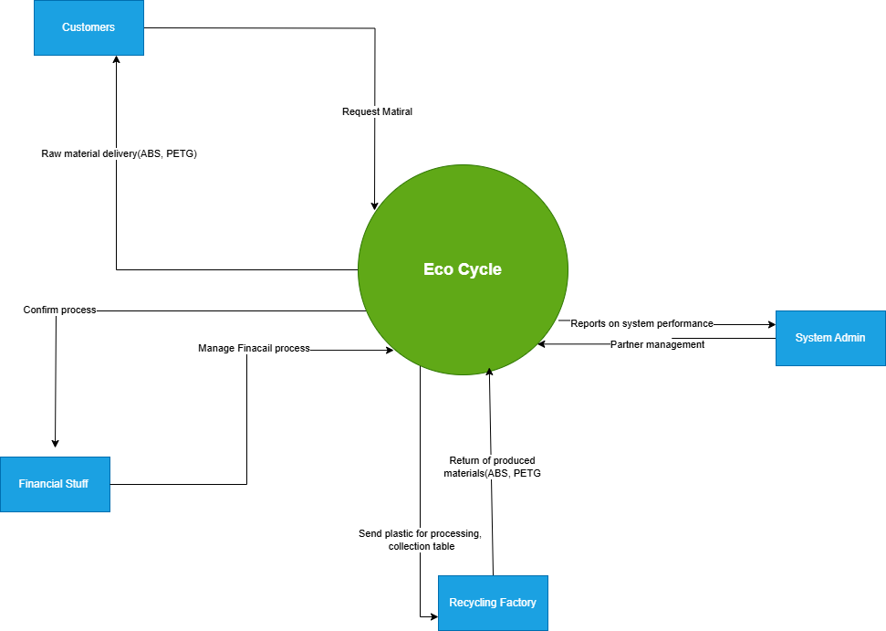
Overview:
The "Eco Cycle" system manages the recycling of materials like ABS and PETG, ensuring efficient coordination between customers, system admins, recycling factories, and financial records.
Components and Interactions:
Entities:
Customers: Request raw materials (ABS, PETG) and confirm the recycling process.
System Admin: Monitors system performance and manages partnerships via reports.
Recycling Factory: Processes and collects plastic, returning processed materials (ABS, PETG).
Financial Table: Manages financial transactions related to recycling.
Central System (Eco Cycle): The "Eco Cycle" system coordinates all interactions, handling material requests, financial processes, and performance reporting.
Processes and Relationships:
-Customers ↔ Eco Cycle: Customers request materials and confirm recycling completion.
-Eco Cycle ↔ Recycling Factory: Sends plastic for processing and receives processed materials.
-Eco Cycle ↔ System Admin: Generates performance and partner reports for the admin.
-Eco Cycle ↔ Financial Table: Manages financial transactions.
Customers ↔ Financial Table: Handles customer payments.
Workflow Summary:
Customers request materials through Eco Cycle, which coordinates with the recycling factory to process plastic and return materials. Financial transactions are tracked via the financial table, and the admin monitors operations through reports. This diagram effectively outlines the Eco Cycle system's role in recycling management, making it a key visual for a graduation project

2.2: Use Case Diagram:
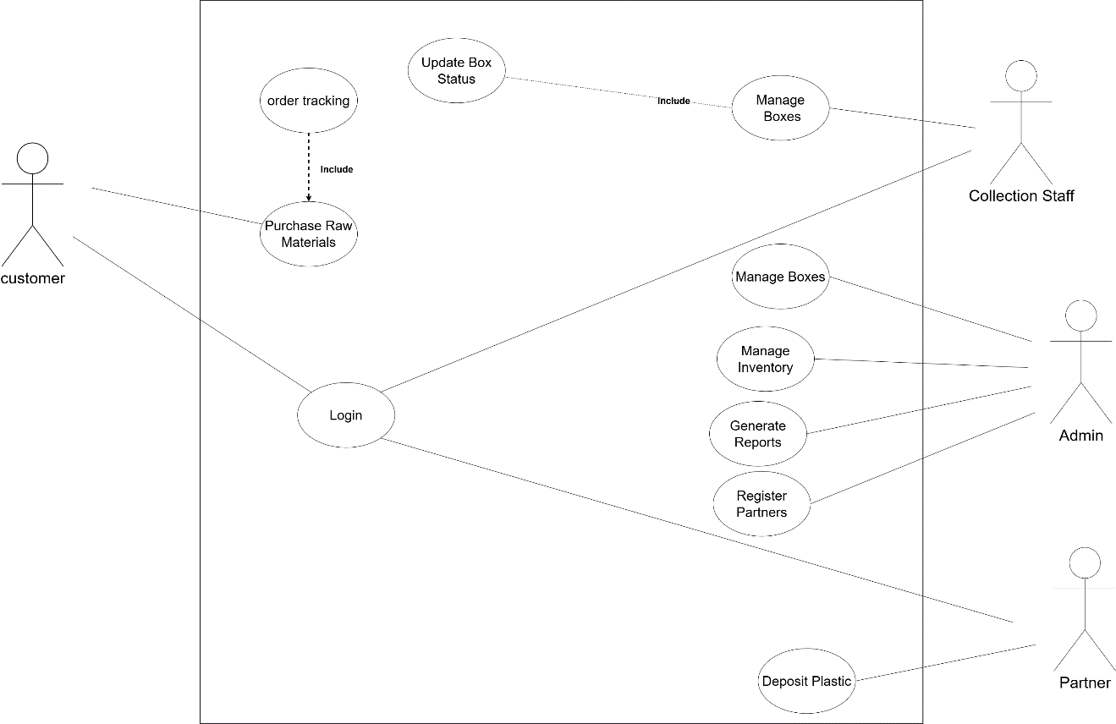
This Use Case Diagram outlines a system designed to manage order tracking, inventory, and material handling, involving multiple user roles including customers, collection staff, admins, and partners.
Components and Interactions:
Actors (Users):
Customer: Engages with the system to track orders and purchase raw materials.
Collection Staff: Manages and updates the status of boxes.
Admin: Oversees inventory, generates reports, and registers partners.
Partner: Deposits plastic into the system.
System Processes (Use Cases):
- Login: The central process that all actors use to access the system.
- Order Tracking: Allows customers to monitor their orders, linked to the "Update Box Status" process.
- Purchase Raw Materials: Enables customers to buy raw materials.
- Update Box Status: Managed by collection staff to include status updates for boxes.
- Manage Boxes: Handled by collection staff to organize and oversee boxes.
- Manage Inventory: Administered by the admin to control stock levels.
- Generate Reports: Performed by the admin to create analytical reports.
- Register Partners: Allows the admin to add new partners to the system.
- Deposit Plastic: Facilitated by partners to contribute plastic materials.
Relationships:
-Customer ↔ System: Customers use "Login" to access "Order Tracking" and "Purchase Raw Materials."
-Collection Staff ↔ System: Collection staff use "Login" to access "Manage Boxes" and "Update Box Status."
-Admin ↔ System: Admins use "Login" to perform "Manage Inventory," "Generate Reports," and "Register Partners."
-Partner ↔ System: Partners use "Login" to perform "Deposit Plastic."
The "Include" relationship indicates that "Order Tracking" includes "Update Box Status" and "Purchase Raw Materials" includes additional material procurement steps.
Workflow Summary:
Users (customers, collection staff, admins, and partners) log into the system to access their respective functionalities.
Customers track orders and purchase raw materials, with box status updates managed by collection staff.
Admins oversee inventory, generate reports, and register new partners.
Partners deposit plastic, contributing to the material cycle. This Use Case Diagram effectively maps out the system's roles and processes, making it a valuable addition to a graduation project to demonstrate the system's user interactions and functionality.

2.3: Activity Diagram: 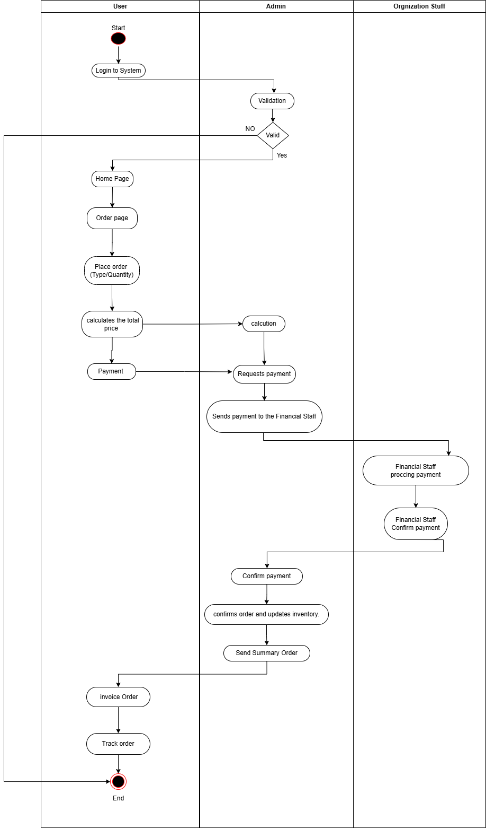
This Activity Diagram illustrates the workflow for placing, processing, and tracking an order, showing the sequence of actions and decision points involving users, admins, and organizational staff, with a focus on payment validation and inventory updates.
Components and Interactions:
1.Participants (Swimlanes):
- User: The individual placing and tracking the order.
- Admin: The system administrator validating the order and managing the process.
- Organizational Staff (Financial Staff):** The team responsible for payment confirmation and processing.
2.Activities and Flow:
User Swimlane:
- Login to System: The process starts with the user logging into the system.
- Home Page: The user navigates to the homepage.
- Order Page: The user accesses the order page.
- Place Order (Type/Quantity): The user specifies the order details (type and quantity).
- Calculates Total Price: The system calculates the total price.
- Payment: The user completes the payment.
- Invoice Order: The user receives an invoice for the order.
- Track Order: The user tracks the order status.
- End: The user’s process concludes.
Admin Swimlane:
- Validation: The admin validates the order with a decision point (Yes/No).
- Calculation: If the order is valid, the admin performs necessary calculations (e.g., payment amount).
- Requests Payment: The admin requests payment from the user.
- Sends Payment to Financial Staff: The admin forwards the payment details to the financial staff.
- Confirms Order and Updates Inventory: After payment confirmation, the admin confirms the order and updates the inventory.
- Send Summary Order: The admin sends an order summary to the user.
Organizational Staff (Financial Staff) Swimlane:
- Processing Payment: The financial staff processes the payment.
- Confirm Payment: The financial staff confirms the payment, notifying the admin.
3.Flow and Decisions:
The process begins with the user logging in and placing an order, specifying type and quantity.
The admin validates the order; if invalid, the process may loop back or terminate (not explicitly shown in the diagram).
If valid, the admin calculates the total, requests payment, and sends the payment details to the financial staff.
The financial staff processes and confirms the payment, allowing the admin to confirm the order, update inventory, and send a summary.
Finally, the user receives the invoice and can track the order until the process ends.
Workflow Summary:
The user logs in, places an order, and completes payment after the admin validates the order. The financial staff confirms the payment, enabling the admin to update inventory and send a summary. The user then tracks the order until the process concludes. This Activity Diagram effectively illustrates the sequential and collaborative workflow, making it a valuable visual for a graduation project to demonstrate the system's operational flow.

2.4: Class Diagram:
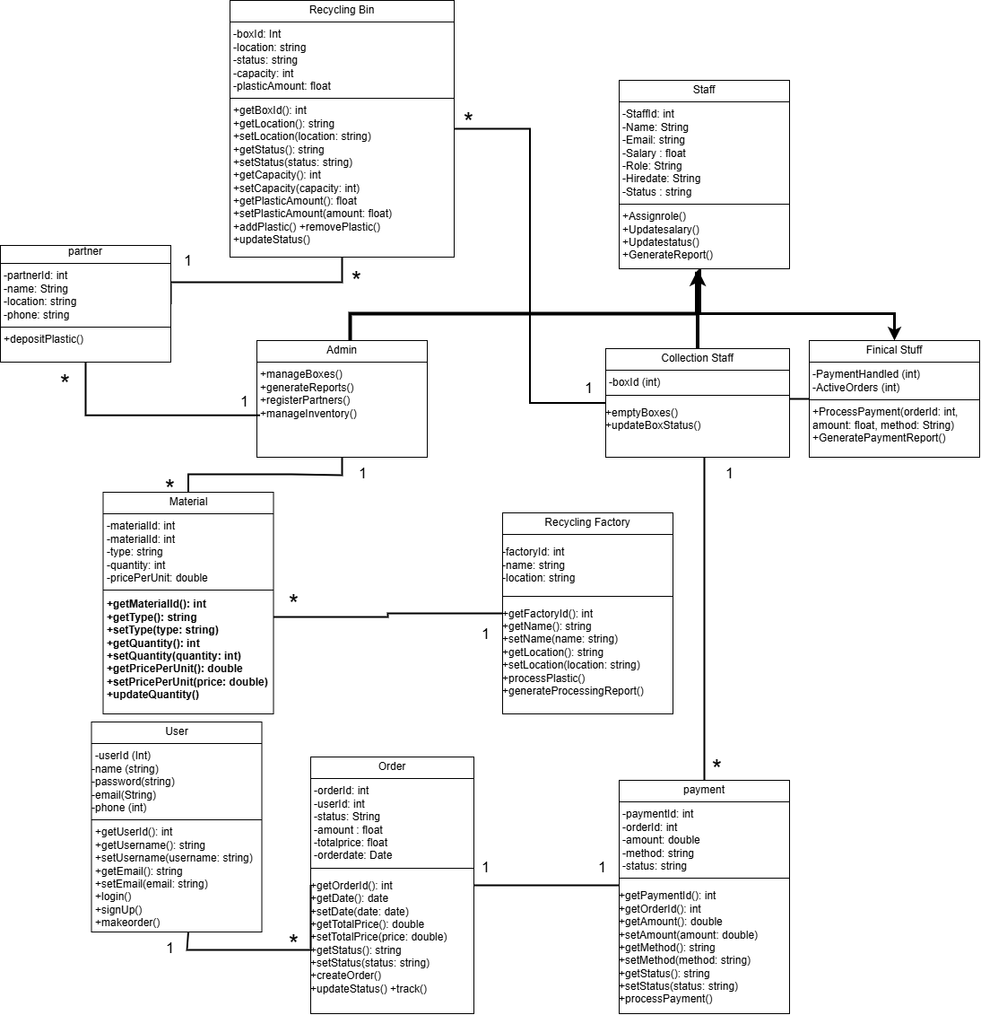
This is a Class Diagram, a type of UML (Unified Modelling Language) diagram that represents the static structure of a system by illustrating its classes, their attributes, methods, and the relationships among them. The purpose of this diagram is to model the entities involved in a recycling factory system, such as users, orders, payments, and inventory, showing how they interact and are structured within the system.
Overview:
This Class Diagram illustrates the structure of a recycling factory management system, detailing the classes involved (e.g., User, Order, Payment, Box, Staff), their attributes, methods, and the relationships between them. It provides a blueprint for how the system’s components are organized and how they interact.
Components and Interactions:
1. Classes and Their Details:
User
- Attributes: userID (int), password (string), email (string), name (string), phone (string), address (string), status (string).
- Methods: getUserID(), setPassword(), getEmail(), setEmail(), update().
- Represents a user who interacts with the system, such as placing orders.
Order
- Attributes: orderID (int), userID (int), amount (float), totalPrice (float), orderDate (date), status (string).
- Methods: getOrderID(), getTotalPrice(), setStatus(), update().
- Represents an order placed by a user, linked to payment and box details.
Payment
  - Attributes: paymentID (int), orderID (int), amount (double), method (string), status (string).
  - Methods: getPaymentID(), setOrderID(), getMethod(), setStatus(), processPayment().
  - Represents payment details for an order, processed by financial staff.
Payment_Financial_Staff (Specialized Class)
- Attributes: activeOrder (int).
- Methods: processPayment_orderID(), confirmPayment().
- A specialized class for financial staff to handle payment processing.

Box
  - Attributes: boxID (int), name (string), status (string), capacity (int), plasticAmount (float), location (string), type (string), price (float).
  - Methods: getBoxID(), setLocation(), setStatus(), getPlasticAmount(), updatePlastic(), addPlastic(), removePlastic().
  - Represents a box used in the recycling process, tracking its status and contents.
Collection (Box)
- Attributes: empty_BoxStatus().
- Methods: emptyBoxes().
- A specialized class for managing the collection of boxes, likely focusing on empty ones.
Recycling Factory
  - Attributes: factoryID (int), name (string), location (string).
  - Methods: getFactoryID(), setName(), getLocation(), update().
  - Represents the recycling factory entity, storing its details.
Material
  - Attributes: materialID (int), name (string), type (string), quantity (int), pricePerUnit (double).
  - Methods: getMaterialID(), setType(), getPricePerUnit(), update().
  - Represents the materials (e.g., plastic) handled in the recycling process.
Partner
  - Attributes: partnerID (int), name (string), phone (string), location (string), depositPlastic().
  - Represents a partner entity, likely involved in supplying or receiving materials.

Staff
- Attributes: staffID (int), name (string), phone (string), salary (float), role (string), status (string).
- Methods: assignOrder(), updateSalary(), generateReport().
- Represents staff members managing the system’s operations.
Admin (Specialized Class of Staff):
- Attributes: None explicitly listed.
- Methods: manageReports(), registerPartners().
- A specialized class for admins, inheriting from Staff, with additional management responsibilities.
2. Relationships:
- User to Order (1 to Many): One user can place many orders (1-to-* relationship).
- Order to Payment (1 to 1): Each order is associated with exactly one payment.
- Order to Box (1 to Many): One order can involve multiple boxes.
- Box to Recycling Factory (Many to 1): Multiple boxes belong to one recycling factory.
- Box to Material (1 to Many): One box can contain multiple materials.
- Box to Partner (Many to 1): Multiple boxes can be associated with one partner.
- Staff to Admin (Inheritance): Admin is a specialized type of Staff (denoted by a triangle arrow).
- Staff to Collection (1 to 1): Staff is linked to the Collection class for managing boxes.
- Payment to Payment_Financial_Staff (Inheritance): Payment_Financial_Staff is a specialized type of Payment.
3. Flow and Structure:
- The diagram starts with the User, who creates Orders. Each order is linked to a Payment, which is processed by the Payment_Financial_Staff.
-The Order involves Boxes, which are part of a Recycling Factory, contain Materials, and may be associated with a Partner.
-The Staff (and its specialized Admin class) oversees the process, managing reports and partners, and handling box collections via the Collection class.
-The structure shows how data flows between entities: a user places an order, the order triggers a payment, and the payment is processed while boxes and materials are managed in the background.
Structural Summary:
The Class Diagram models a recycling factory system where a User places Orders, each associated with a Payment and involving Boxes. Boxes are linked to a Recycling Factory, contain Materials, and may involve a Partner. The Staff (including Admins) manages the process, handling collections and reports. This diagram provides a clear static structure of the system, making it a valuable blueprint for a graduation project to demonstrate the system’s design and relationships.

2.5: Sequence Diagram:
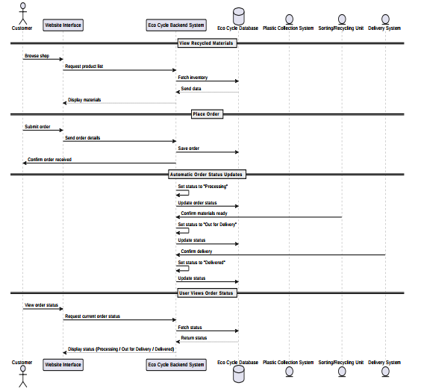

Overview:
This Sequence Diagram illustrates the interaction flow between a customer and the recycling system’s components as the customer browses recycled materials, places an order, and tracks its status. It shows the step-by-step communication between the customer, the website interface, and the backend systems, including status updates handled by the system components.

Components and Interactions:
1. Participants (Lifelines):
  - Customer: The individual interacting with the system.
  - Website Interface: The front-end interface the customer uses to interact with the system.
  - Eco Cycle Backend System: The main backend system that processes requests and coordinates with other components.
  - Eco Cycle Database: The database that stores order and material data.
  - Plastic Collection System: The system responsible for confirming material readiness.
  - Sorting/Recycling Unit: The system that handles material sorting and recycling.
  - Delivery System: The system responsible for delivering the order.
2. Interactions and Flow:
View Recycled Materials:
  - The customer initiates the process by browsing the shop through the Website Interface.
  - The Website Interface sends a "request product list" message to the Eco Cycle Backend System.
  - The Backend System fetches the inventory from the Eco Cycle Database.
  - The Database sends the data back to the Backend System.
  - The Backend System forwards the data to the Website Interface, which displays the materials to the customer.

Place Order:
  - The customer submits an order via the Website Interface.
  - The Website Interface sends the order details to the Eco Cycle Backend System.
  - The Backend System saves the order in the Eco Cycle Database.
  - The Database confirms the order has been received back to the Backend System.
  - The Backend System notifies the Website Interface, which confirms to the customer that the order has been received.
Automatic Order Status Updates:
  - The Eco Cycle Backend System begins updating the order status automatically.
  - It sets the status to "Processing" and updates the Eco Cycle Database.
  - The Backend System confirms material readiness with the Plastic Collection System.
  - The Backend System sets the status to "Out for Delivery" and updates the Database.
  - The Backend System confirms delivery with the Delivery System.
  - The Backend System sets the status to "Delivered" and updates the Database.
User Views Order Status:
  - The customer requests the current order status through the Website Interface.
  - The Website Interface forwards the request to the Eco Cycle Backend System.
  - The Backend System fetches the status from the Eco Cycle Database.
  - The Database returns the status to the Backend System.
  - The Backend System sends the status (e.g., "Processing," "Out for Delivery," or "Delivered") to the Website Interface.
  - The Website Interface displays the status to the customer.
3.Flow and Sequence:
-The process starts with the customer browsing the shop and requesting a product list, which is retrieved from the database and displayed.
-The customer places an order, which is saved in the database, and the customer receives confirmation.
-The system automatically updates the order status through stages (Processing, Out for Delivery, Delivered) by interacting with the Plastic Collection System, Delivery System, and Database.
-Finally, the customer checks the order status, which is retrieved from the database and displayed.
Interaction Summary:
The Sequence Diagram models the interaction flow of a recycling system where a customer browse recycled materials, places an order, and tracks its status. The Website Interface communicates with the Eco Cycle Backend System, which coordinates with the Database, Plastic Collection System, Sorting/Recycling Unit, and Delivery System to process the order and update its status. This diagram provides a clear view of the message exchanges and system interactions, making it a valuable tool for a graduation project to demonstrate the system’s operational flow.

Chapter 3

System Design

3.1: Database Design (ERD Diagram):
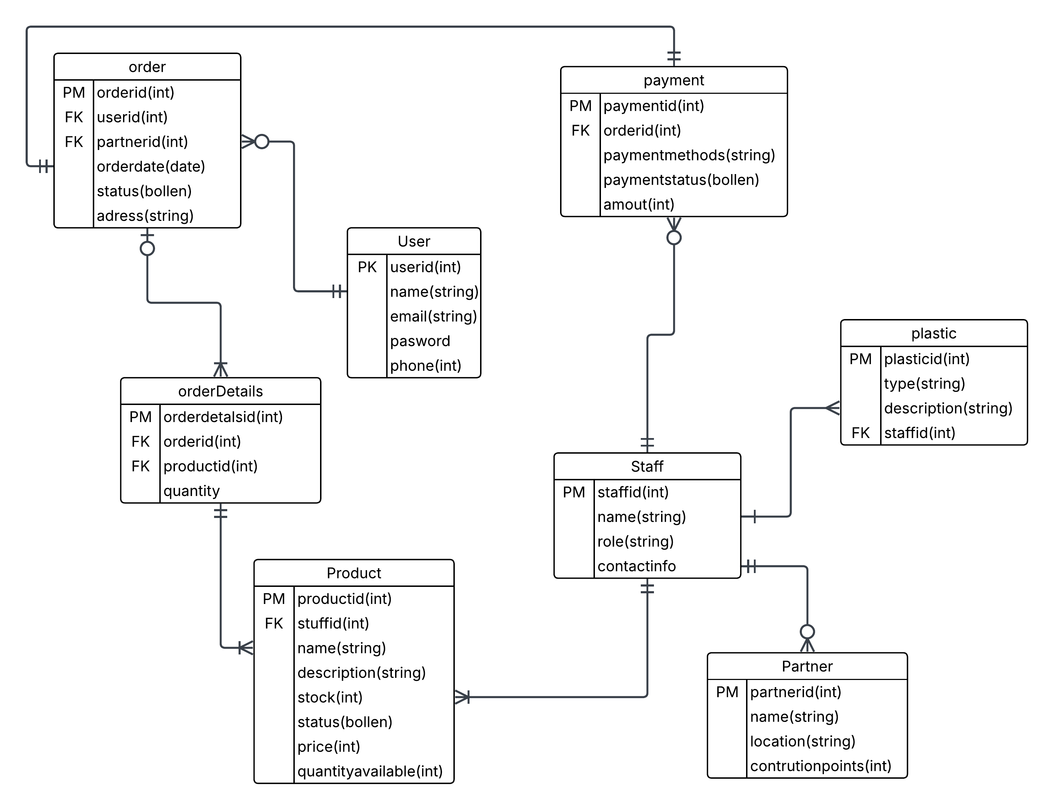
Overview:
This Entity-Relationship Diagram (ERD) illustrates the structure and relationships between tables in a system managing orders, users, products, payments, and related entities, such as staff, partners, and plastic materials. It provides a clear representation of the database schema, showing how data is organized and linked for an e-commerce or recycling system.
Components and Relationships:
1. Entities (Tables):
  - Order: Represents customer orders.
  - User: Represents registered users of the system.
  - Partner: Represents business partners or suppliers.
  - orderDetails: Contains details of items within each order.
  - Product: Represents available products or materials.
  - Staff: Represents employees managing products or materials.
  - payment: Represents payment transactions for orders.
  - plastic: Represents specific plastic material records.
2. Attributes and Relationships:
Order Table:
Attributes:
- orderid (Primary Key): Unique identifier for the order.
- userid (Foreign Key): Links to the User table.
- partnerid (Foreign Key): Links to the Partner table.
- orderdate: Date of the order.
- status: Order status (true/false).
- address: Delivery address.
Relationships:
- Connected to User via userid (one user can place multiple orders).
- Connected to Partner via partnerid (one partner can handle multiple orders).
- Linked to orderDetails and payment (one order can have multiple details and payments).
User Table:
Attributes:
- userid (Primary Key): Unique identifier for the user.
- name: User’s name.
- email: User’s email address.
- password: User’s password.
- phone: User’s phone number.
Relationships:
- Linked to Order (one user can have multiple orders).

Partner Table:
Attributes:
- partnerid (Primary Key): Unique identifier for the partner.
- name: Partner’s name.
- location: Partner’s location.
- contrubtionpoints: Contribution points of the partner.
Relationships:
- Linked to Order (one partner can manage multiple orders).
orderDetails Table:
Attributes:
- orderdetailsid (Primary Key): Unique identifier for order details.
- orderid (Foreign Key): Links to the Order table.
- productid (Foreign Key): Links to the Product table.
- quantity: Quantity of the product ordered.
Relationships:
- Connected to Order (one order can have multiple details).
- Connected to Product (one product can appear in multiple order details).
Product Table:
Attributes:
- productid (Primary Key): Unique identifier for the product.
- staffid (Foreign Key): Links to the Staff table.
- name: Product name.
- description: Product description.
- stock: Available stock.
- status: Product status (true/false).
- price: Product price.
- quantityavailable: Available quantity.
Relationships:
Connected to Staff (one staff member can manage multiple products).
Linked to orderDetails (one product can be part of multiple order details).
Staff Table:
Attributes:
- staffid (Primary Key): Unique identifier for the staff member.
- name: Staff member’s name.
- role: Staff member’s role.
- contactinfo: Contact information.
Relationships:
- Linked to Product (one staff member can manage multiple products).
- Linked to plastic (one staff member can manage multiple plastic records).
payment Table:
Attributes:
- paymentid (Primary Key): Unique identifier for the payment.
- orderid (Foreign Key): Links to the Order table.
- paymentmethods: Payment method used.
- paymentstatus: Payment status (true/false).
- amount: Payment amount.
Relationships:
Connected to Order (one order can have multiple payments).
plastic Table:
Attributes:
- plasticid (Primary Key): Unique identifier for the plastic record.
- type: Type of plastic.
- description: Plastic description.
- staffid (Foreign Key): Links to the Staff table.
Relationships:
Connected to Staff (one staff member can manage multiple plastic records).
3. Relationship Summary:
One-to-Many (1:N) Relationships:
User → Order: One user can place multiple orders.
Partner → Order: One partner can handle multiple orders.
Order → orderDetails: One order can have multiple details.
Order → payment: One order can have multiple payments.
Product → orderDetails: One product can be part of multiple order details.
Staff → Product: One staff member can manage multiple products.
Staff → plastic: One staff member can manage multiple plastic records.

3.2: UI/UX Design (Screen Design):
Login / Sign

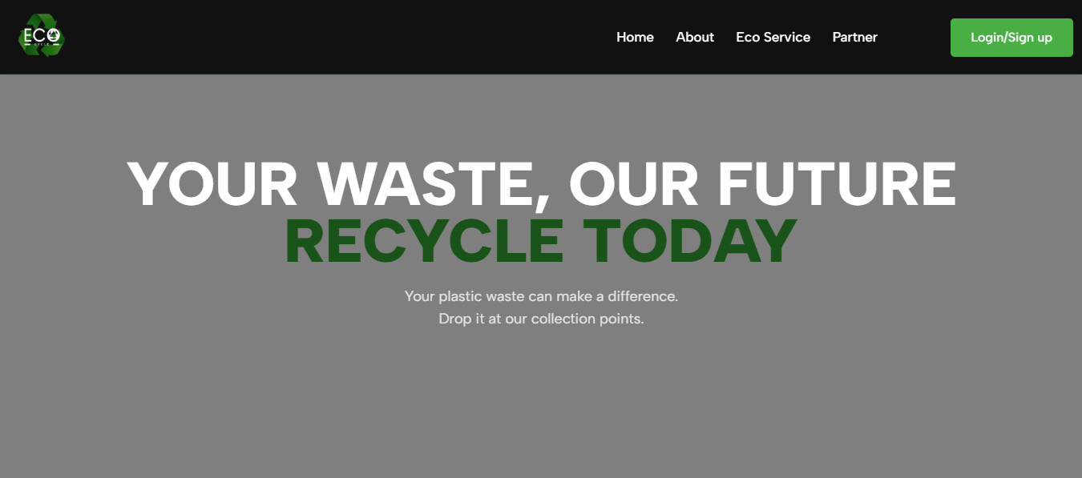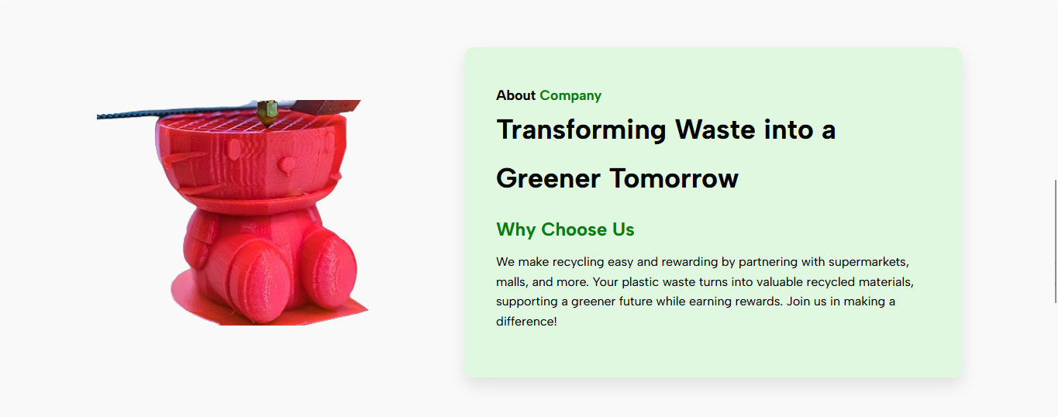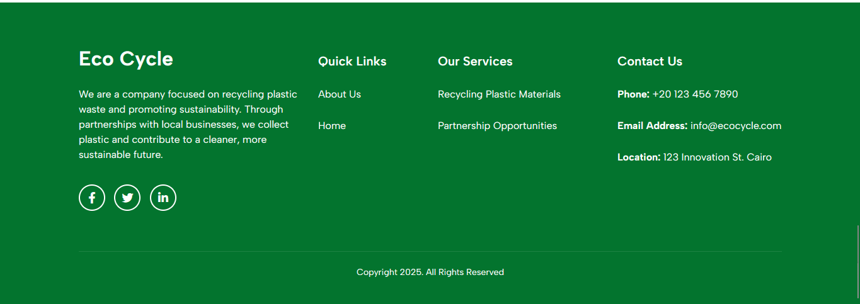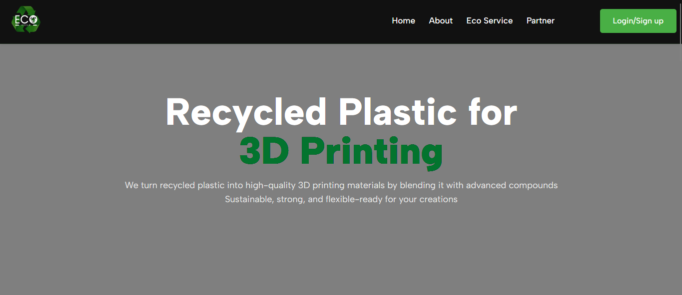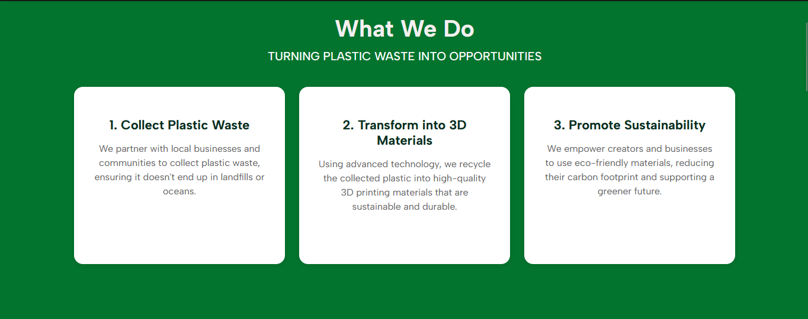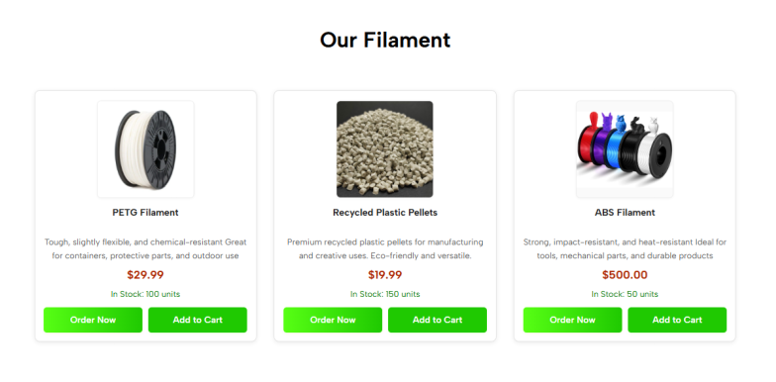

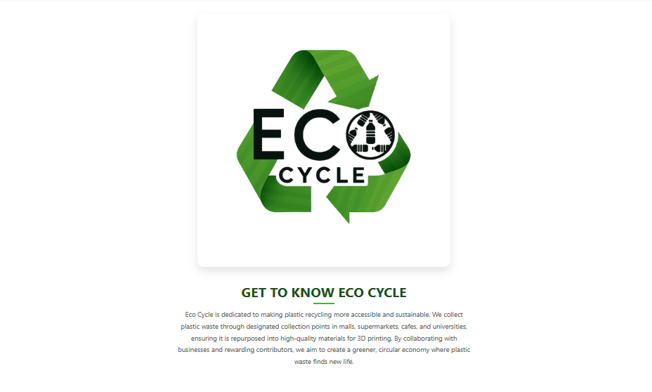
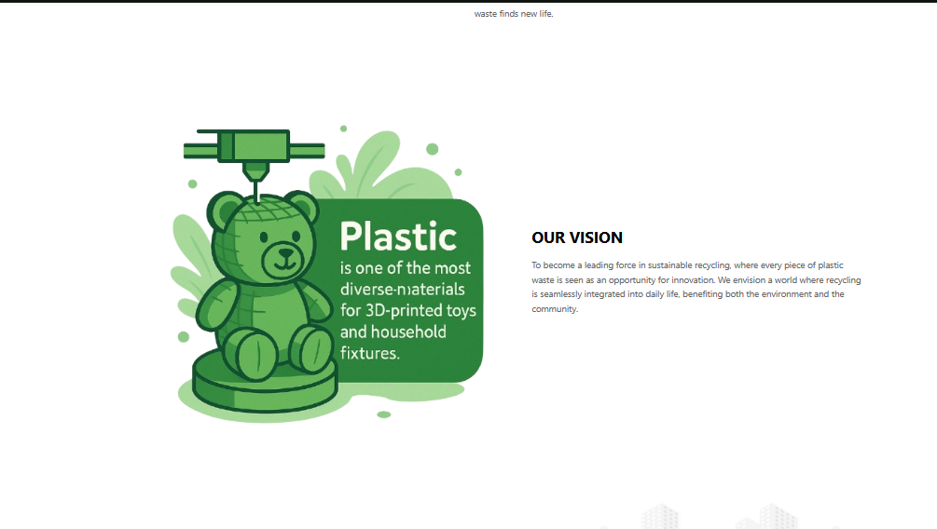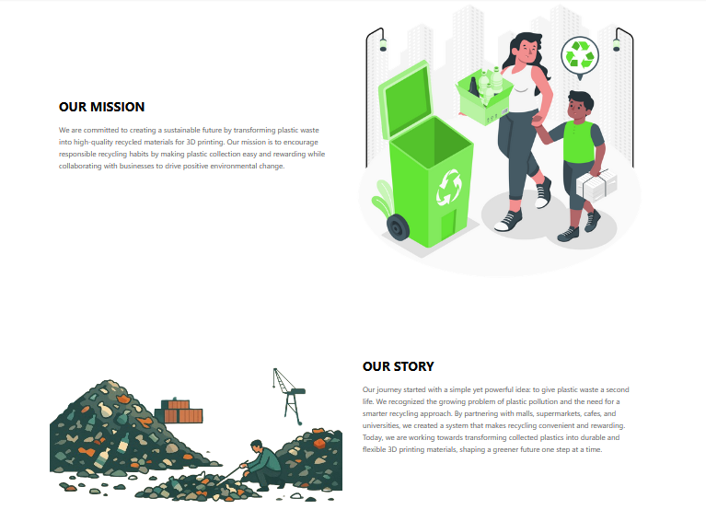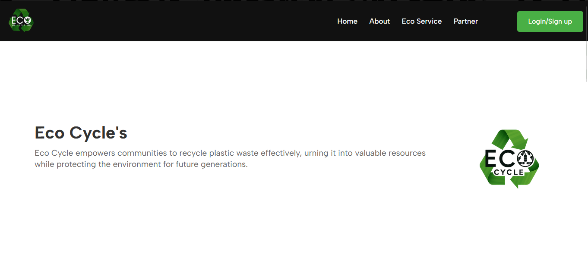
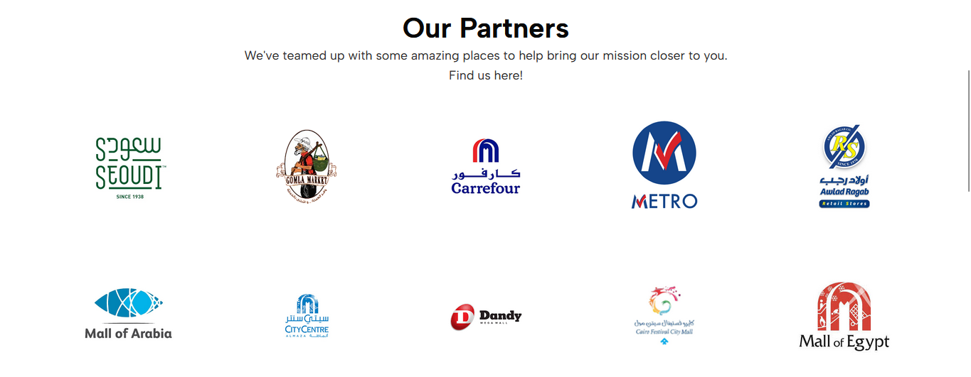
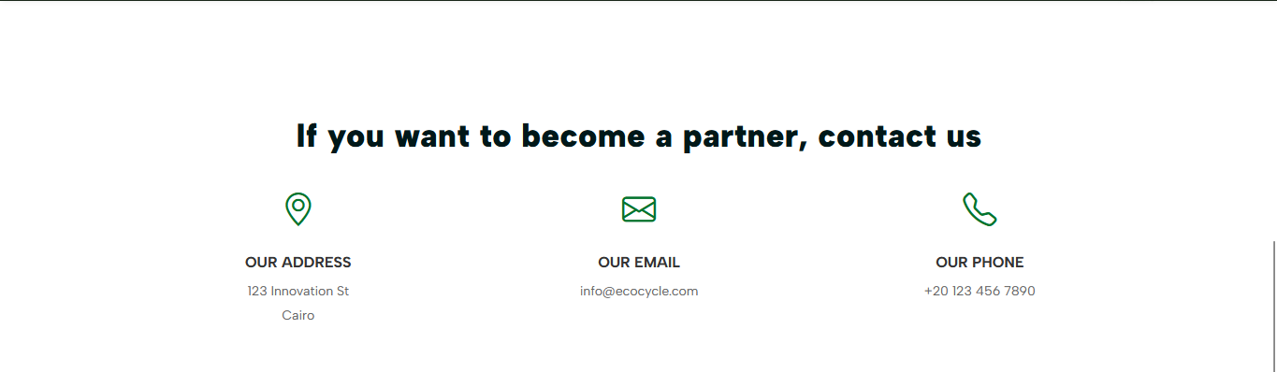

Chapter 4

Implementation

Signup
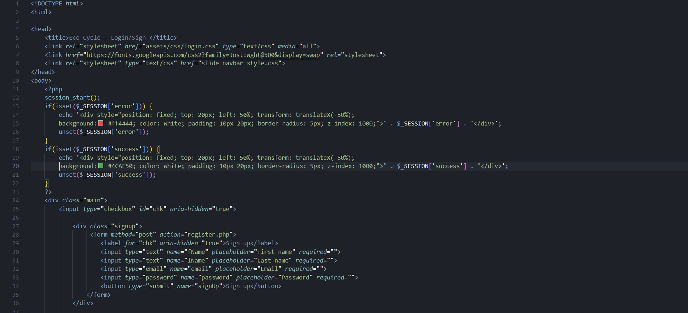
Login
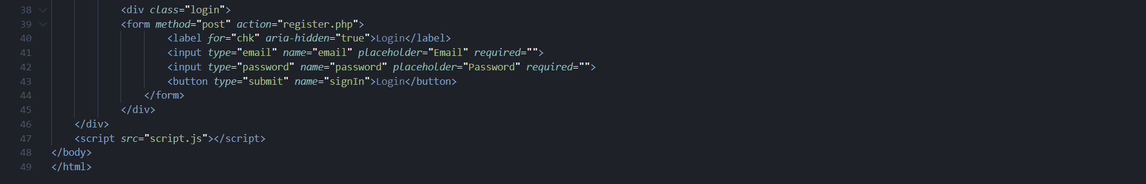
Logout
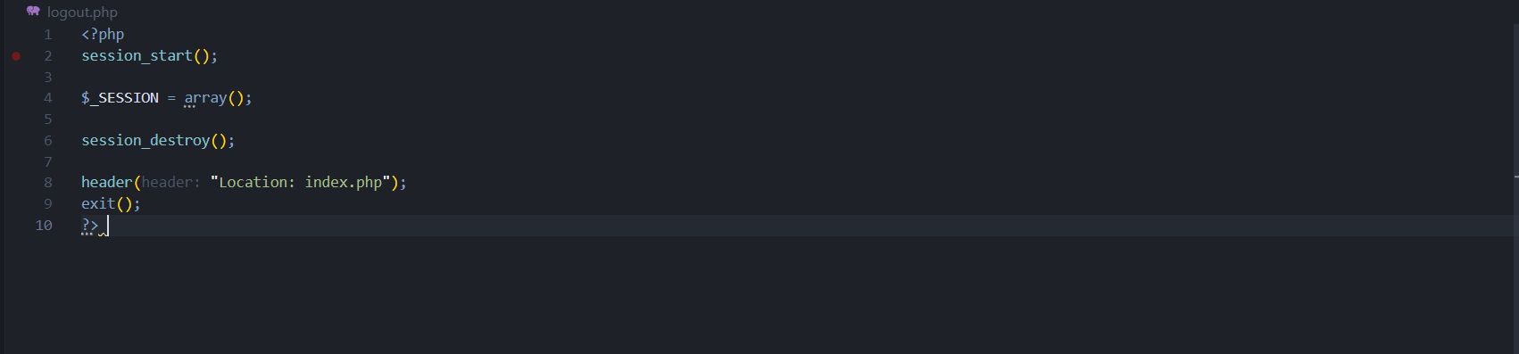
Add products
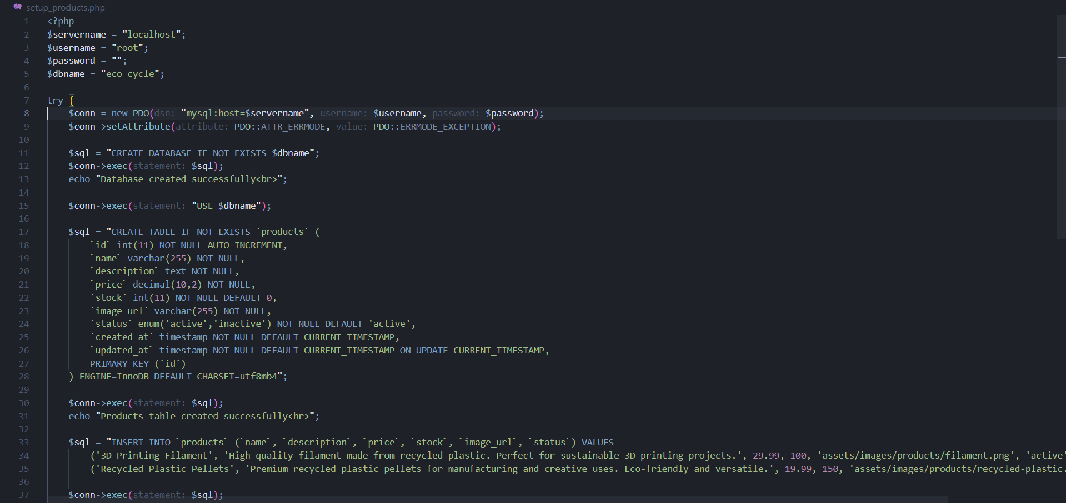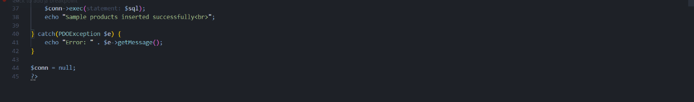

Order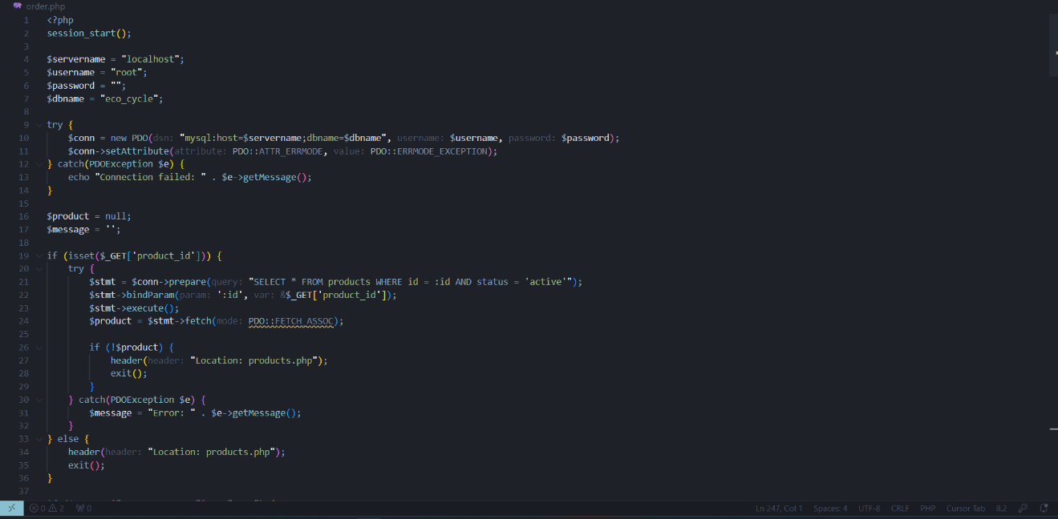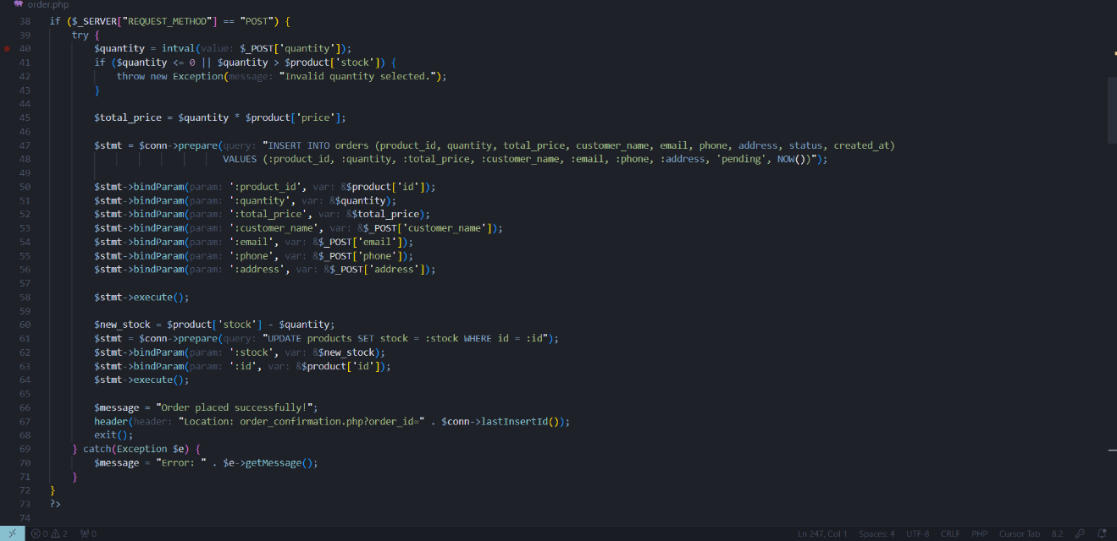
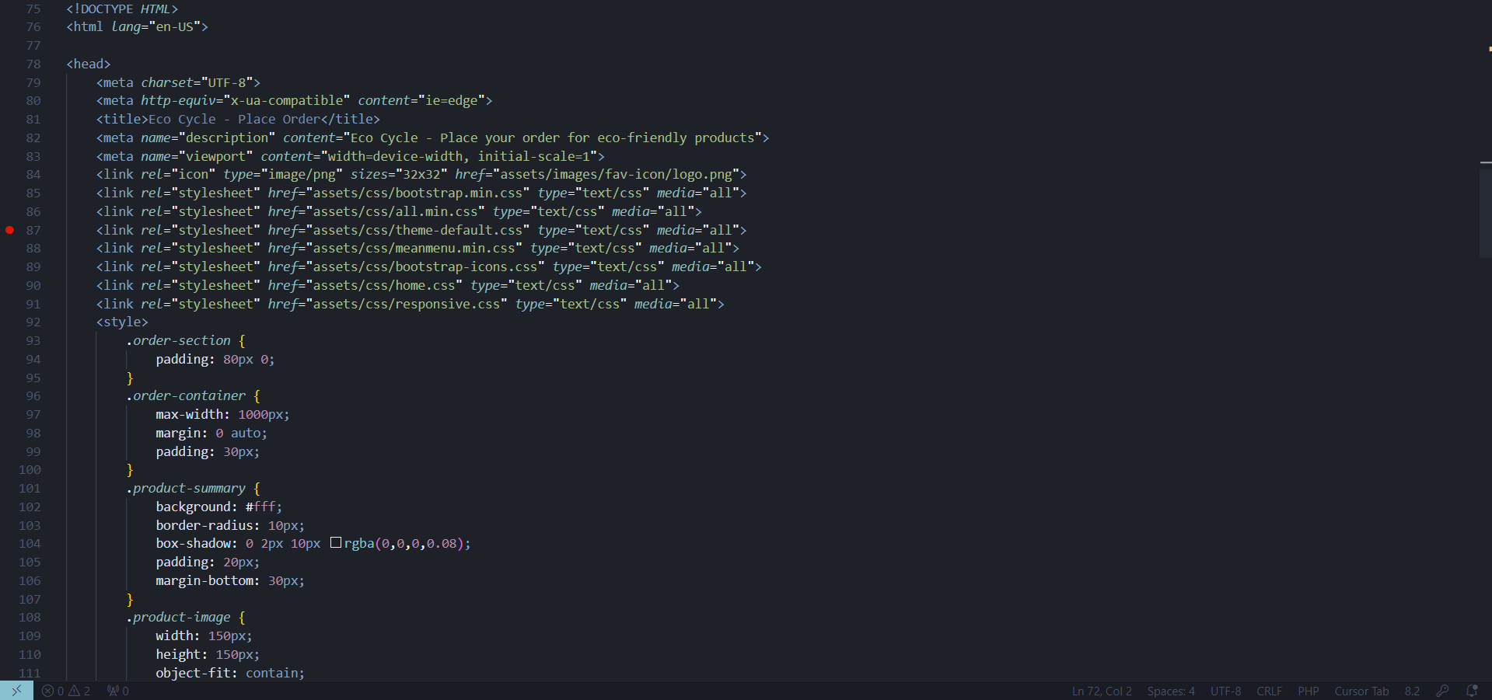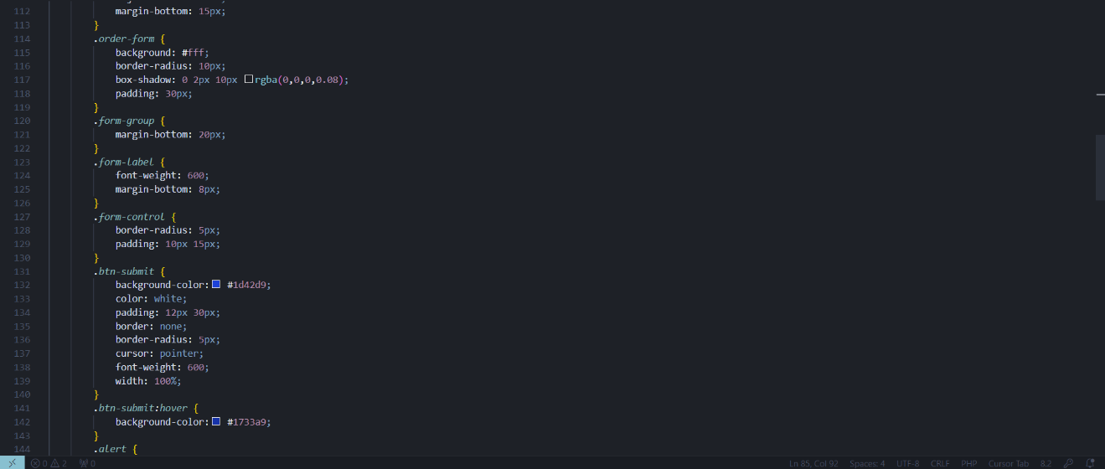
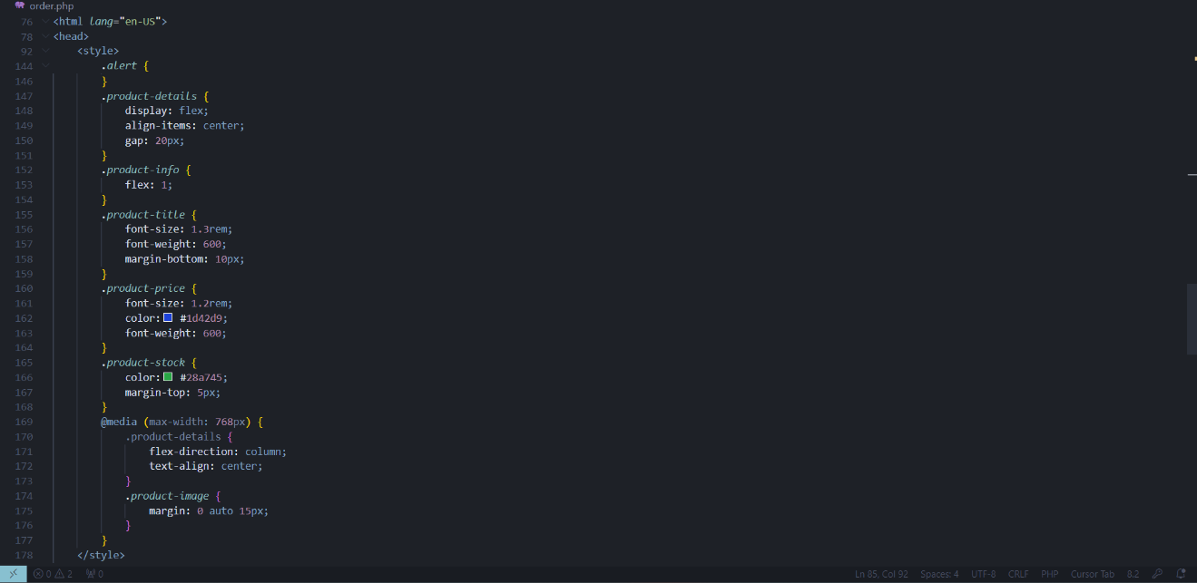
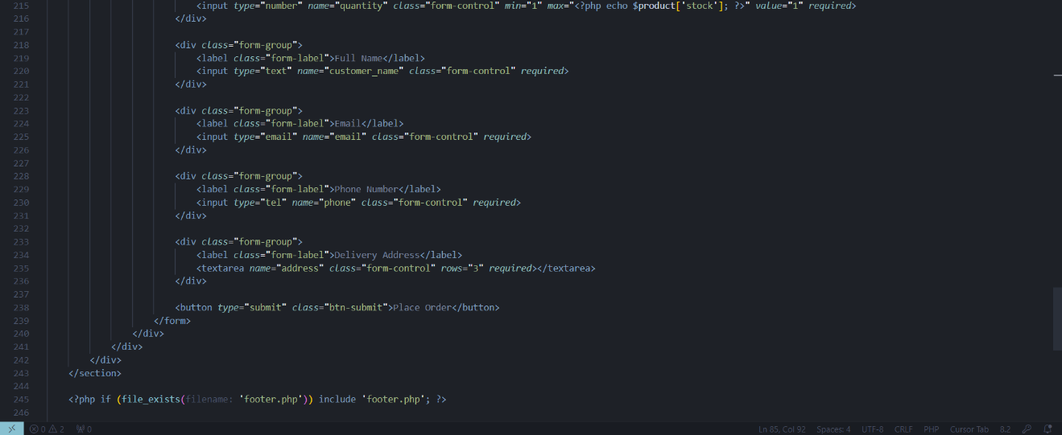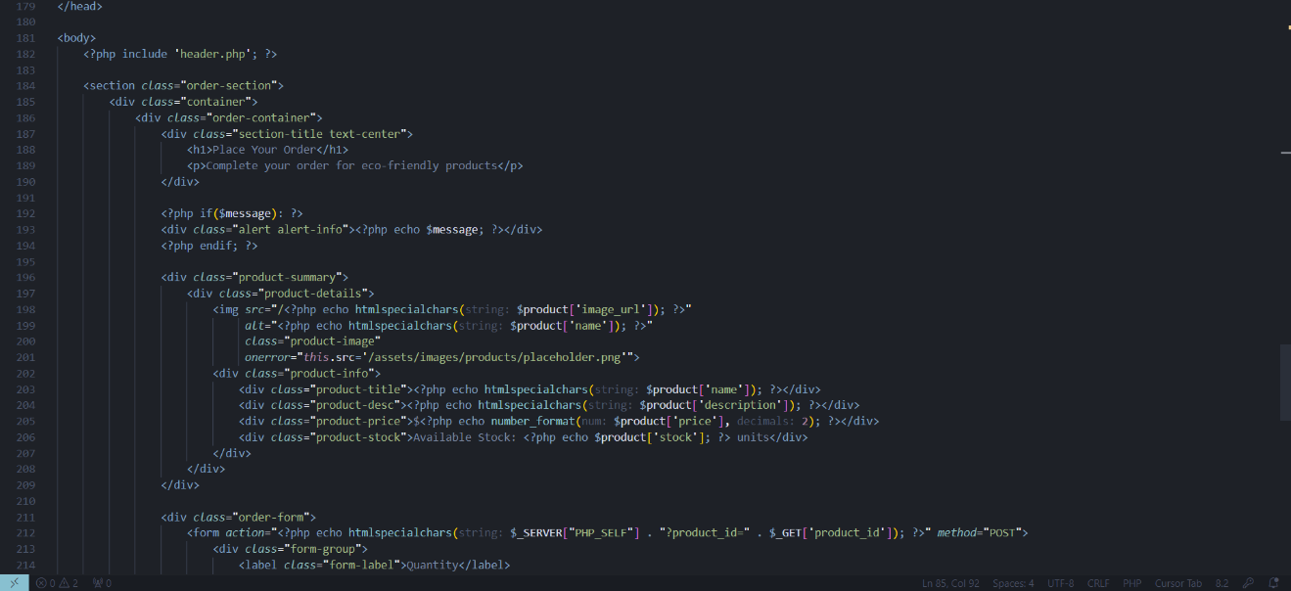
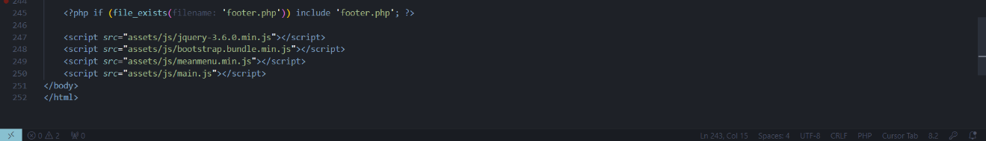

submit order to Database
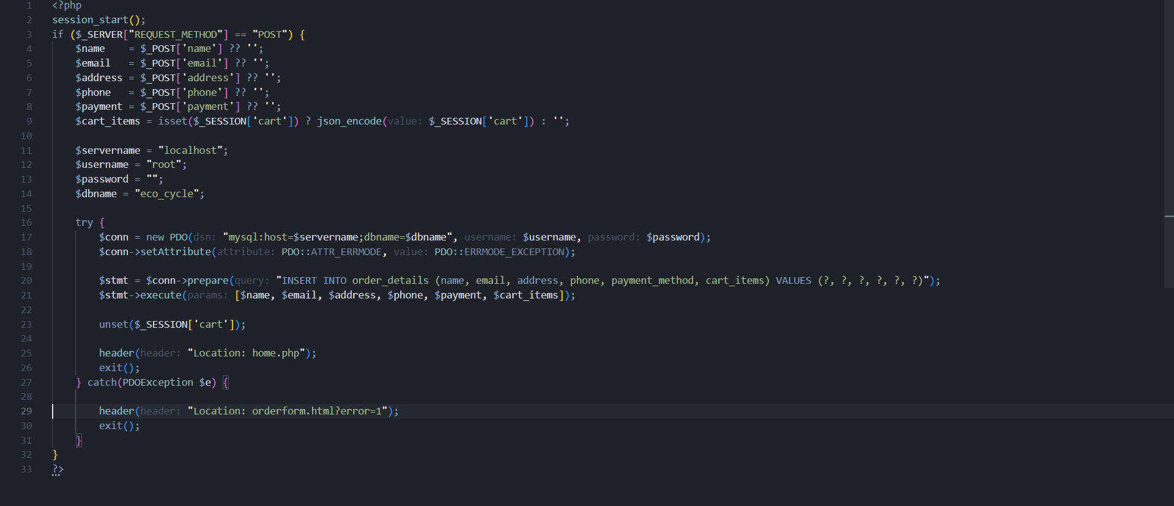

Cart
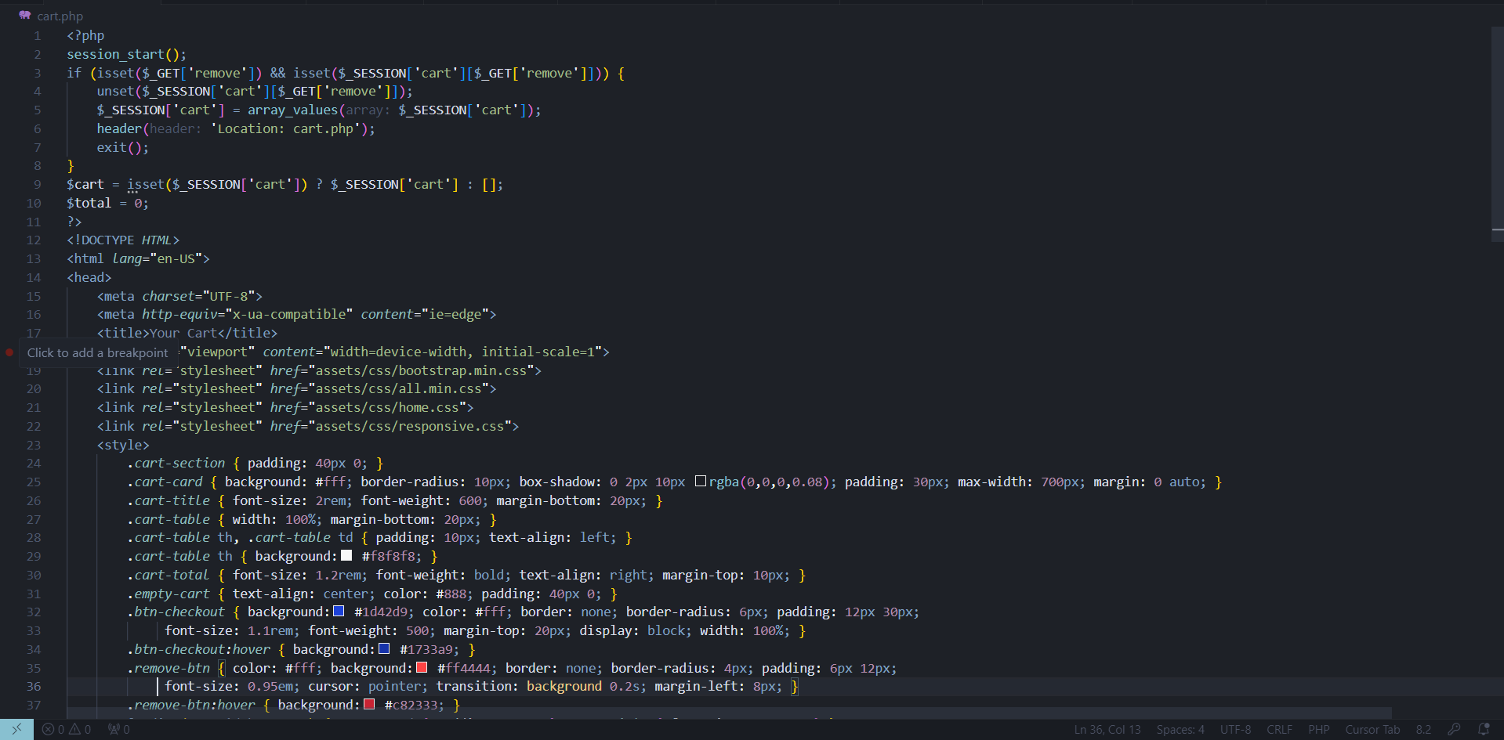
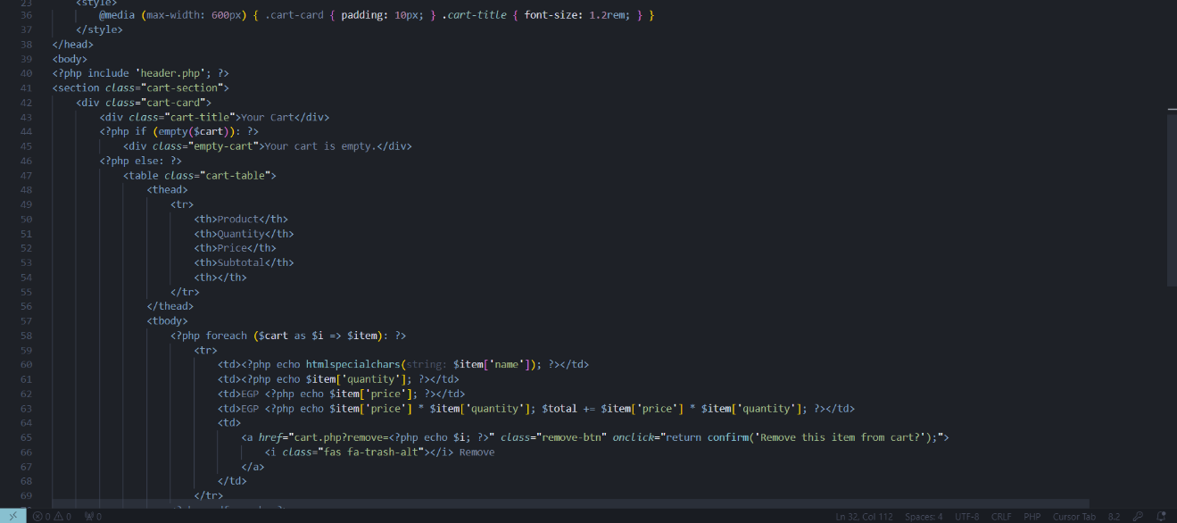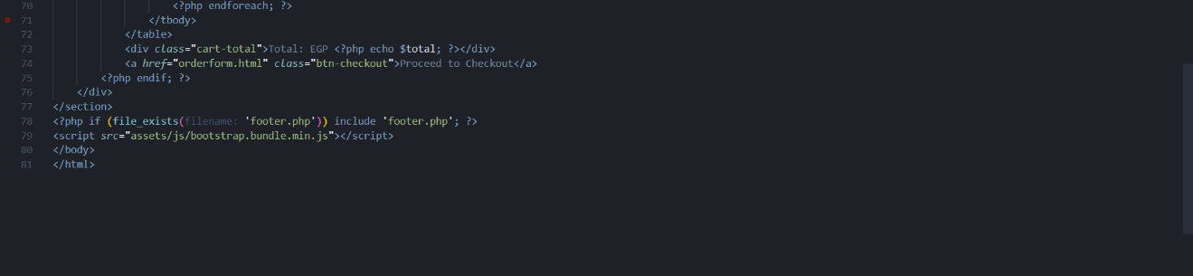
API Connect Website with Database
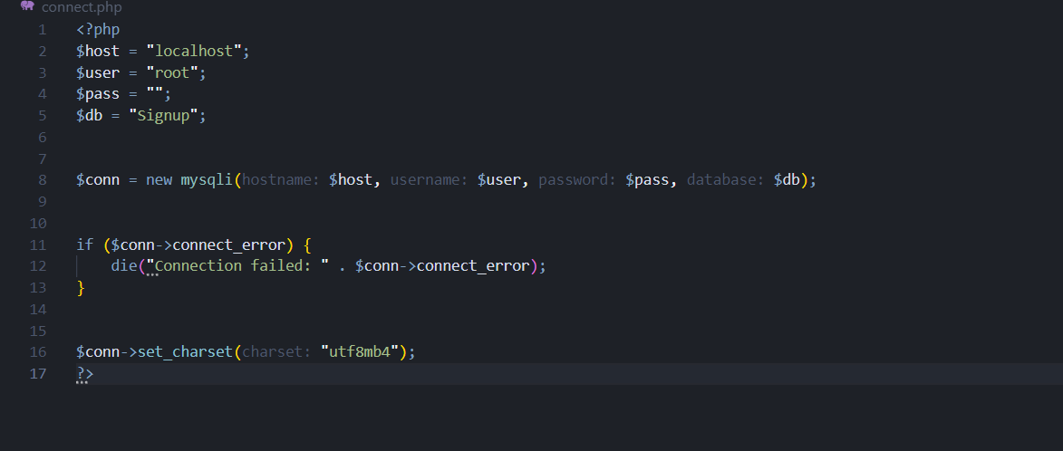
API Connection between site and company database
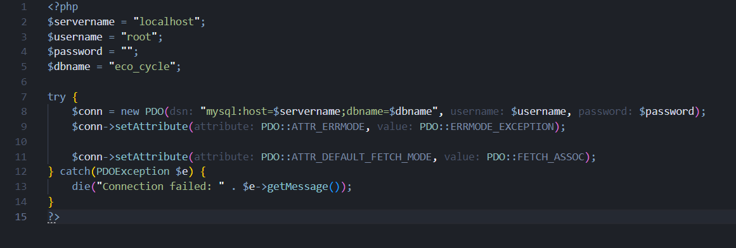

Service
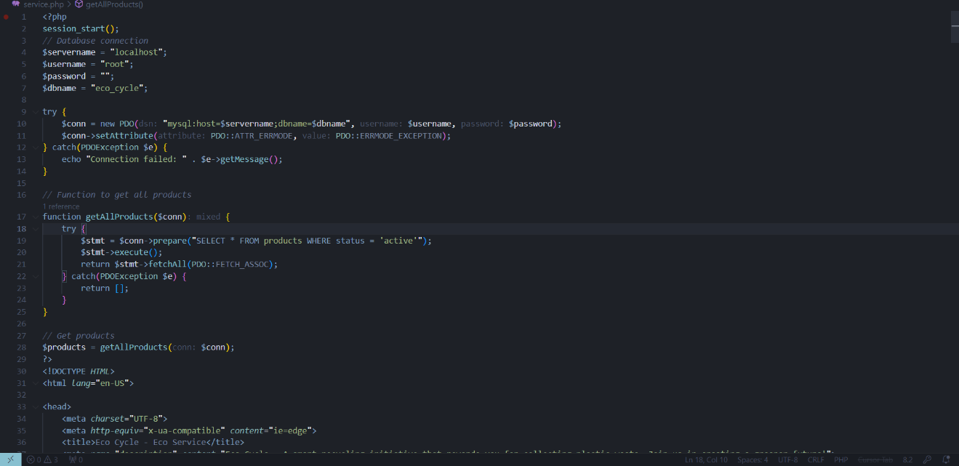

Retrieve order details from the Database to To display it to admin in the orders tap/button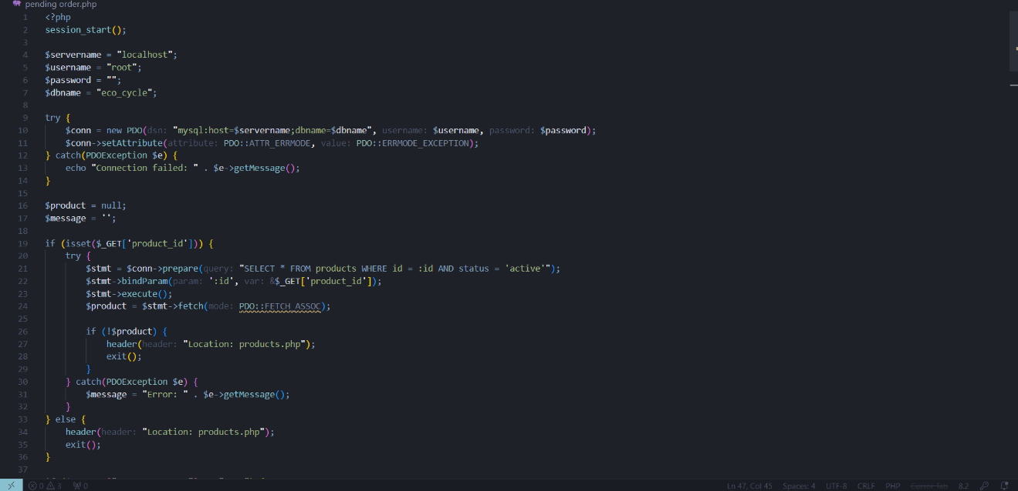
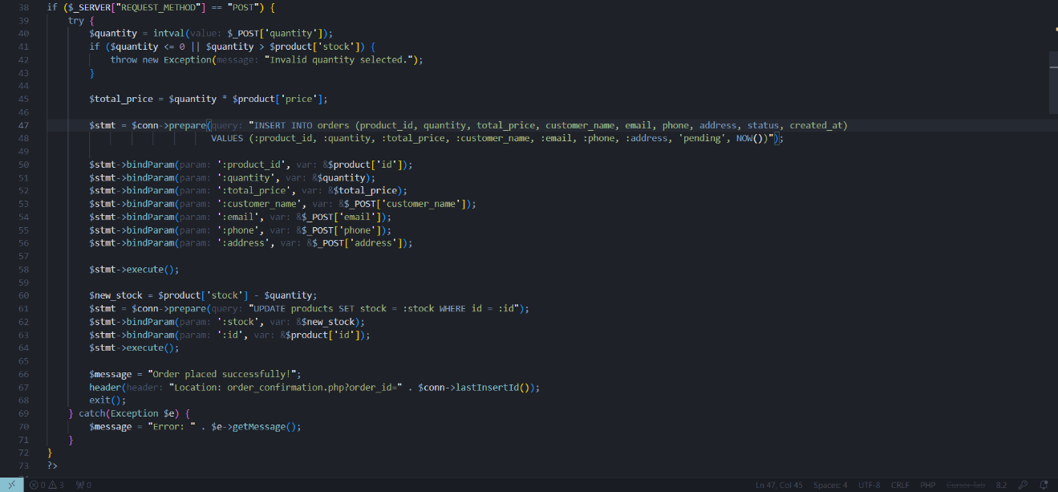

Chapter 5

Conclusion and Future Work

5.1: Conclusion:
The Eco Cycle project represents a practical and forward-thinking approach to one of the most pressing environmental challenges of our time: plastic waste. By combining technology, sustainability, and community engagement, the system offers a clear and effective method for collecting, sorting, and recycling plastic into reusable materials.
Through the development of a dynamic website, the platform facilitates transparency, accessibility, and efficiency in every stage of the recycling process. Users can easily find collection points, learn about recycling, and purchase eco-friendly products—while companies and institutions can contribute to sustainability by partnering in plastic collection and, eventually, product creation.
This project not only provides a technical solution but also promotes long-term environmental awareness and behavioral change. With room for future growth, including the integration of 3D printing for customized products, **Eco Cycle** lays the foundation for a scalable, impactful, and socially responsible recycling ecosystem.
Ultimately, this project reflects our commitment to innovation and sustainability—offering a model that can be replicated and expanded to create a cleaner, greener future.

5.2: Future Work:
Integration of 3D Printing Services: One of the most significant future goals is to implement 3D printing capabilities that allow partners and customers to request customized eco-friendly products made from recycled plastic, such as educational models, decorative items, and branded merchandise.
- User Accounts and Reward System: Introducing user registration and a points-based reward system can encourage regular participation. Users could earn points for donations, which can later be redeemed for discounts or products.
- Mobile Application Development: Launching a dedicated mobile app for both Android and iOS would improve accessibility and user engagement, especially for locating drop-off points or placing orders on the go.
- Smart Collection Tracking: Implementing QR codes or smart ID tags at collection points can help track the volume and type of plastic collected from each location, improving data accuracy and efficiency.
- Real-Time Inventory Updates: Adding automation to inventory management would allow customers to see livestock updates of recycled materials and receive notifications when new products are available.
- Partner Portal: A dedicated dashboard for partner organizations to track collection stats, request printed products, and access promotional materials to spread awareness.
- Expansion to Other Types of Waste: In the long term, the platform could be adapted to manage and recycle other materials, such as paper, metal, or electronic waste, making it a broader sustainability platform.
These planned enhancements aim to increase the platform’s usability, efficiency, and environmental impact, ensuring that Eco Cycle continues to evolve as a powerful tool for sustainable development.

